1. A simple pendulum may be used to determine a value for the acceleration of free fall g.
Measurements are made of the length L of the pendulum and the period T of oscillation.
The values obtained, with their uncertainties, are as shown.
T = (1.92 ± 0.02) s
L = (91 ± 1) cm
(a) Calculate the percentage uncertainty in the measurement of
(i) the period T,
= 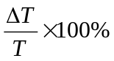
= 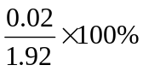
= 1.04 % -----A(1)
uncertainty = ………1.0……. % [1]
(ii) the length L.
= 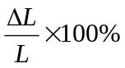
= 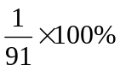
= 1.10 % -------A(1)
uncertainty = ……1.1……. % [1]
(b) The relationship between T, L and g is given by
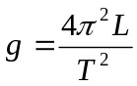
Using your answers in (a), calculate the percentage uncertainty in the value of g.
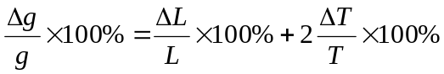
= 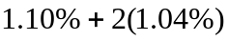…..C(1)
= 3.2 % ----A(1)

uncertainty = …3.2% [2]
(c) The values of L and T are used to calculate a value of g as 9.745 m s^{–2}.
By reference to the measurements of L and T, suggest why it would not be correct
to quote the value of g as 9.745 m s^{–2}.
raw data are measured in 2 and 3 sf, therefore, the measured g should be quoted as 2 sf or 3 sf but not 4 sf------- (B1)
Or actual uncertainty is ±0.3ms⁻² ---------(B1) [1]

(b) An object is acted upon by two forces at right angles to each other. One of the forces
has a magnitude of 5.0 N and the resultant force produced on the object is 9.5 N.

Determine
- the magnitude of the other force,
9.5 N
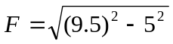 ----C(1)
= 8.1 N-----A(1)
5 N
force = 8.1N [2]

(ii) the angle between the resultant force and the 5.0 N force.
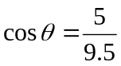------C(1)
= 58 ° ------A(1)

angle = 58° [2]

2. (a) Distinguish between the mass and the weight of a body. State the unit in which each is measured.
mass of a body is a measure of the inertia of the body. S.I unit is kg –B(1)_
Weight of a body is the gravitational force exerted on that body. S.I unit is Newton B(1). [2]

(b) In the Unites States, plans are under consideration for launching a satellite by use of a space gun. The satellite, of mass 2000 kg, accelerates uniformly along a tube of length 1200 m and reaches a speed of 8000 ms⁻¹
Calculate:
- the momentum of the satellite as it leaves the tube
p= mv
= 2000 (8000) ---C(1)
= 1.6 10⁷ Ns ---A(1) momentum = 1.6 10⁷ …kgms⁻¹ [2]

- the time it takes to accelerates along the tube
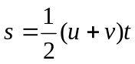
1200 = 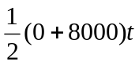 ----(1)
t = 0.30 s ----(1) time taken = …0.30. s [2]

- the force causing the acceleration
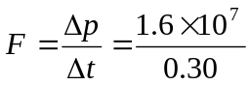 ----C(1)
= 5.33 10⁷ N ---A(1)
force = ….5.33 10⁷ …..N [2]

(c) (i) It would be impossible to use gun in (b) for mannered space flights. Suggest a reason.
the enormous force that is required to produce the high acceleration will kill any astronaut in the space vehicle-------B(1)…………………………………………. [1]

(ii) It would be an advantage to site the gun on Earth’s equator pointing eastwards. Suggest a reason.
As the Earth rotates eastward, the speed of the satellite will be enhanced B(1)………………………………. [1]

- Figure3.1 shows an athlete of mass 65 kg about to perform a pole vault.
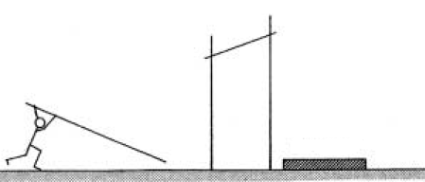
Figure 3.1
Landing mat

The centre of gravity athlete rises 4.2 m during the vault.
(a) Calculate the change in potential energy of the athlete between take off and reaching the highest point.
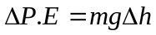
= 65 (9.81) (4.2) ----C(1)
= 2680 J ---A(1)
change in potential energy = 2680……J [2]

(b) Assuming that the centre of mass falls the same distance when falling. Calculate
the vertical speed, in m s⁻¹, of the athlete when he lands.
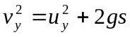
= 2 (9.81) (4.2) -----C(1)
v_{y} = 9.1 ms⁻¹ ----A(1)
vertical speed = ……………………ms⁻¹ [2]
(c) Explain how the landing mat reduces the force experienced by the athlete to an
acceptable level when landing.
Increases the time taken for the athlete ----M(1)
to come to rest/ reduced deceleration -----A(1)................................... OR [2]
Impact force reduced because F = mv – mu /t ----- A(1)

- An object of mass 3.0 × 10³ kg is suspended from a steel cable of length 40 m and cross-sectional area 1.0 × 10⁻⁴ m². Determine the extension of the cable when this mass-cable system
- is at rest
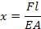

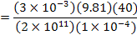 -------C(1)
= 5.89 × 10⁻² m ----A(1)

extension = …5.89 × 10⁻² m …….m [2]

- moves upwards at constant speed
Since the system moves without acceleration, the tension F is still equal to mg.
Hence, x = 5.89 × 10⁻² m ---A(1)
extension = ……5.89 × 10⁻⁸ m ….m [1]

- moves upwards at constant acceleration 3.0 ms⁻²
F – mg = ma
F = (3 × 10³)(9.81 + 3)
= 38.4 × 10³ N
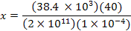 --------C1)

= 7.7 × 10⁻² m ----A(1)
extension = …7.7 × 10⁻² m …….m [2]
Assume the cross-sectional area to be constant.
(Young’s modulus for steel = 2.0 × 10¹¹Pa; g = 9.81 ms⁻²)
.
5. a. Explain what is meant by interference. (Nov 06) [2]
When two waves meet at a point ------ B[1]
There is a changes in overall intensity --------- B[1]

b. In the diagram below S₁ and S₂ are two continuous harmonic sound sources each of
which emit sound of wavelength 0.70m. As an instrument that detects sound
intensity is moved along the line AB it registers a series of maximum sound
intensities and minimum sound intensities.
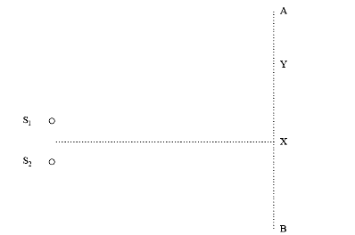

Fig. 5

The first maximum registered is at X and the first minimum at Y.
The distance S₁X = S₂X.
- If the distance S₁Y is 3.0m what is the distance S₂Y equal to?
Explain your answer. [2]
3.35m -------A[1]
For destructive interference at Y the path difference between the waves
must be 1/2λ. ------B[1]

- Describe and explain what will happen to the distance between the first
maximum and the first minimum if the frequency of the sound from the two
sources is increased. [2]
Will decrease. -------A[1]
X= lamda * L/ a, wavelength is directly prop to fringe spacing, freq increases, wavelength decreases
OR
Since λ goes down, and therefore path difference will be smaller. -----M[1]

- The sound waves in part (b) produce interference effects. Natural light do not
produce observable interference effects. Explain why the loudspeakers are
able to produce interference effects but the natural light do not. [2]
Speakers act as coherent sources or have constant phase difference. ---B[1]
Natural light is not coherent or phase relation not constant. ------B[1]

6. Imagine two equal masses, connected by a light rigid link, carrying equal but
opposite charges. This is a system called a dipole. Fig.6.1 and Fig 6.2 show the
dipole placed in different orientations between two uniformly and oppositely
charged plate.

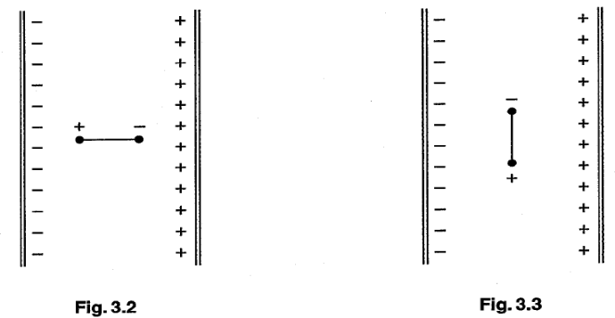
Fig. 6.1 Fig. 6.2

Any effects of gravity are negligible.

- Describe the electric forces acting on the charges by drawing suitable arrows on the Fig 6.1. [1]
Equal and opposite forces drawn on each figure in correct directions. ----A(1)

- Explain the motion, if any, of the dipole when it is released from rest
  - In Fig 6.1 [2]
No motion ----A[1]
as electric forces on charges are equal and opposite. -----M[1]

  - In Fig 6.2 [2]
The dipole rotates to/ oscillates about the position in Fig.3.2 -----B[1]
Because a couple is formed/ no translation motion/ rotation clockwise ----B[1]
(inally , wil be stationary when the dipole is parallel to the field streng

7. A set of Christmas lights has 46 lamps in a series circuit connected across the 230V
mains. One of the lamps is shown in Fig.7.1.

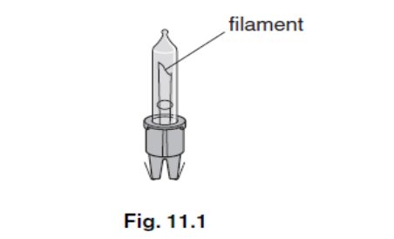
Fig.7.1

The p.d. against current relationship for the filament is shown in Fig. 7.2.

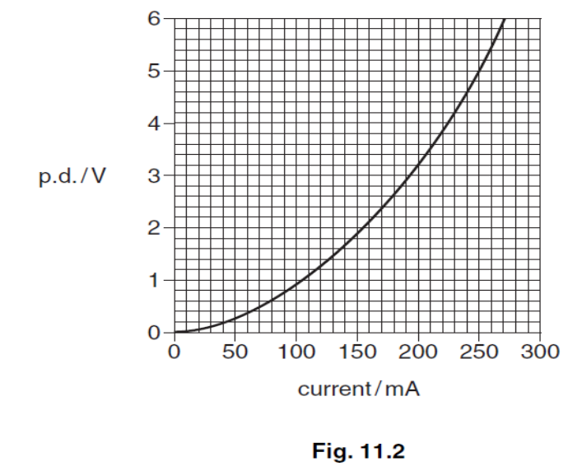
Fig. 7.2

a. Show that the potential difference across each lamp is 5V when lit normally.
230/46 = 5.0V ------A[1]

Potential Difference = …………………. V [1]

b. Calculate the resistance of each lamp filament when lit normally.
R = V / I = 5 / 0.25 ----C[1]
= 20Ω ------A[1]

Resistance = ………………………… Ω [2]
- In another set of 46 Christmas light the same lamps are used, but a 60Ω resistor in the lamp holder is connected in parallel with each lamp as shown in Fig. 7.3.

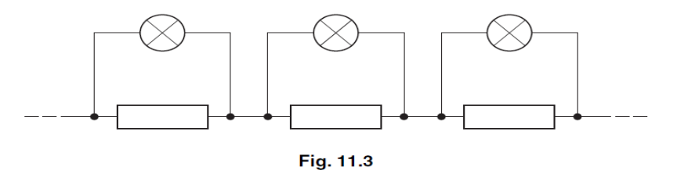

Fig. 7.3

  - Suggest a reason for this design with a resistor in parallel with each filament.
If one filament blows remaining lamps stay on. --------B[1]

2. Calculate the current drawn from the main supply by this set of lamps.
Each bulb 1/R = 1/20 + 1/60 and R = 15Ω -----C[1]
Total R = 15 x 46 = 690Ω -------C[1]
I = (230 / 690) = 0.33A --------A[1]

Current = ……………………………. A [3]

3. The filament breaks in one of the lamps.
State and explain what will happen to the brightness of the other 45 lamps.
Brightness dims (slightly) ----A[1]
A parallel path is removed so resistance in this position rises and
current drops. ------M[1]

- In another set of lights which are meant to be identical to the set in part (c) there
is a manufacturing fault. The 60 Ω resistor has been omitted from one of the
lamp holders.
Suggest and explain what will happen to the brightness of the lamp in the holder
compared to the other 45 lamps.
Brightness rise because resistance at this position rises -------A[1]
So voltage across lamp increases ---------M[1]
(no longer a parallel resistor to take some of the current)

- a. Fig.8.1 shows the apparatus used to investigate Rutherford scattering, in which α particles are fired at a gold foil.

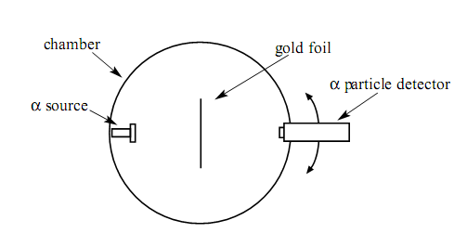

Figure 8.1

- Why is it essential for there to be a vacuum in the chamber?
To prevent the α particles being absorbed by air molecules. ----B [1]

- What observations made with this apparatus support each of the following conclusions? No explanation is required?

  - The nuclear radius of gold is much smaller than its atomic radius.
Little or no deflection by a majority of α particle. -------B[1]
  - Most of the mass of an atom of gold is contained in its nucleus.
Some α particles suffer large deflection. -----B[1]

- Fig. 8.2 shows α particles incident on a layer of a atomics in a gold foil.
On this figure draw the complete path followed by each of the α particles shown.

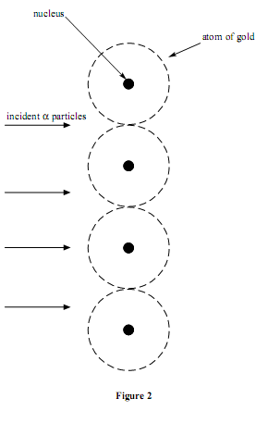
First path continues undeflected. B[1] Second path deflected downwards. B[1]
Third path shows backscattering. B[1]

Fig.8.2
[3]

